Introduction to CSS

# 2nd Course in the Web Design for Everybody: Basics of Web Development & Coding Specialization

# About Course

# Skills You Will Gain

**Cascading Style Sheets (CSS)**

**Web Development**

**Style Sheets**

Web Design

# Course Materials

General Links

*Additional Reading*

*Beyond Scope*

# Week

## Styling your text

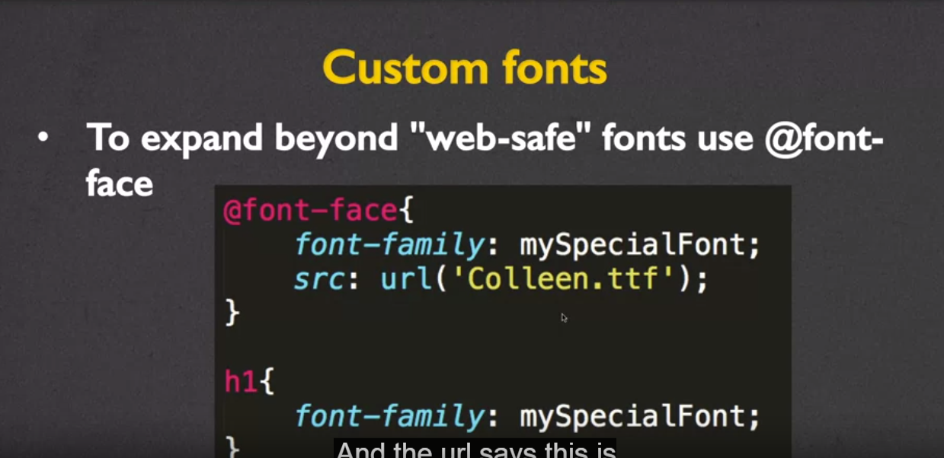

Line-height

This property will adjust the space between the lines of text

p{

line-height: 50%;

}

## Display and Visibility

Block –span entire row

Inline-Block – block element that accepts both width and height (allowing block elements to share a row)

Display None – hide the element

Float property

* Reposition elements to the right or left.
* Elements are aware of one another and will not overlap.
* Values: left, right

Clear property

* Used to keep floating elements away
* Values: left, right, both

Overflow property

Values:

* visible: Can cause text to show up “on top” of other text
* hidden: Hides anything that goes beyond bounding box
  + note this can cause problems if the user increases font size, they may not be able to see content
* scroll: Gives horizontal and vertical scrollbars
* auto: Adds scrollbars as needed

Display table and display table-cell

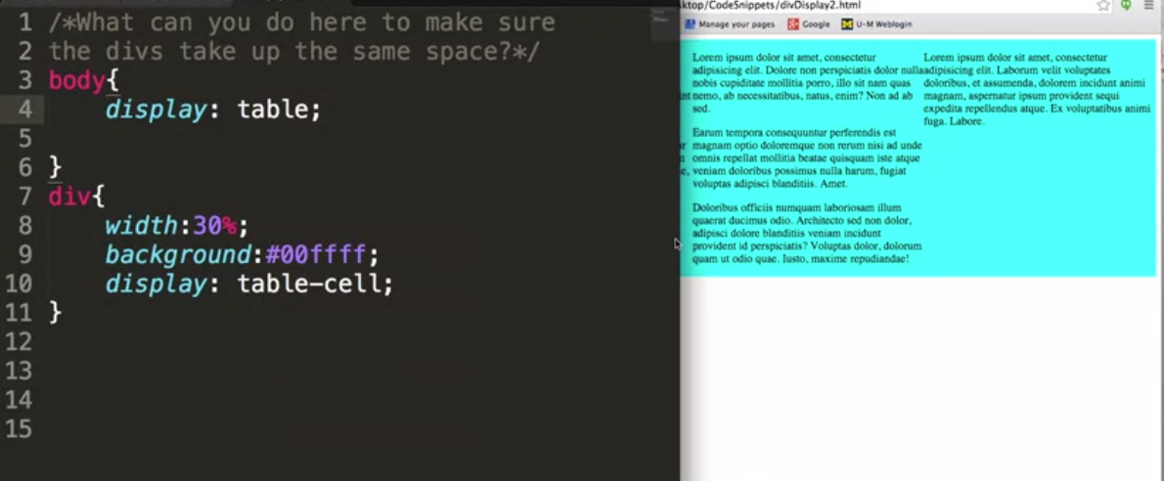

Visibility Property

This property specifies whether or not an element is visible.(note this element will still occupy the space it consumes)

Values:

* visible
* hidden
* collapse (only for table elements)

Week 1

Notes

Links

Closing Thoughts

Week 2

## The Box Model

### Centering an Element

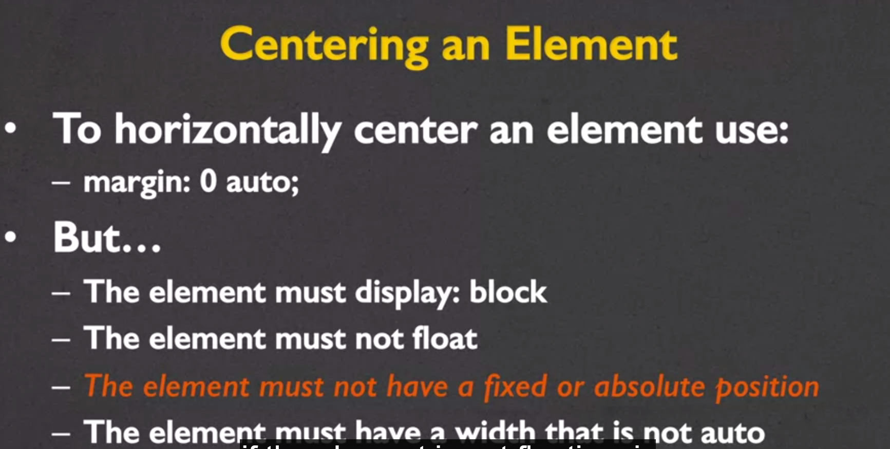

### Box-sizing

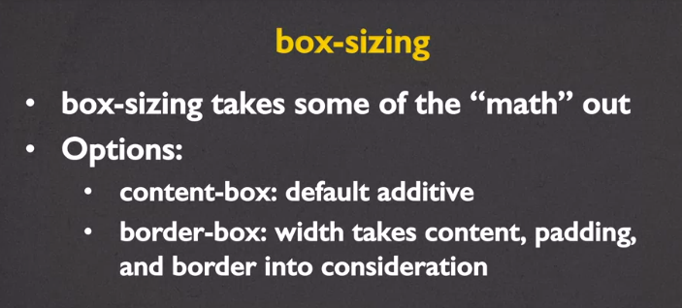

## Styling Links and Lists

### Anchors <a>

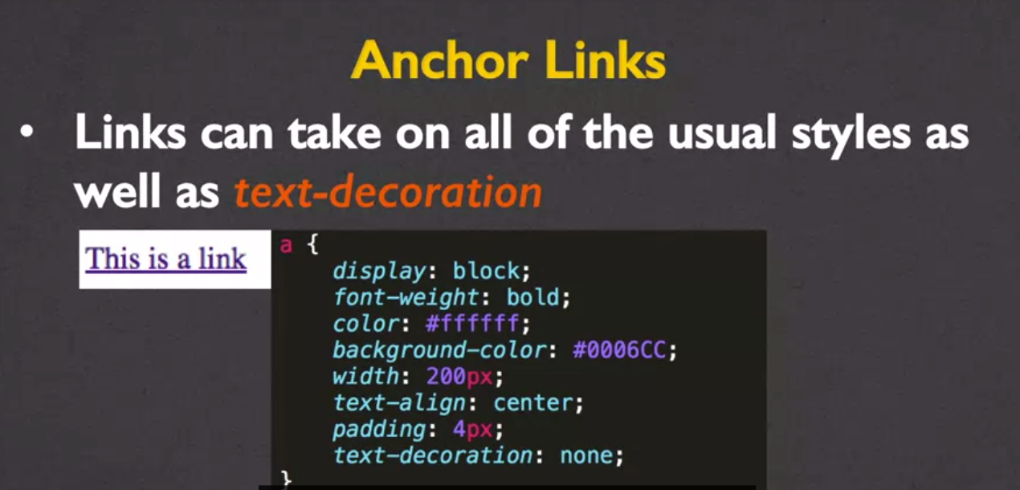

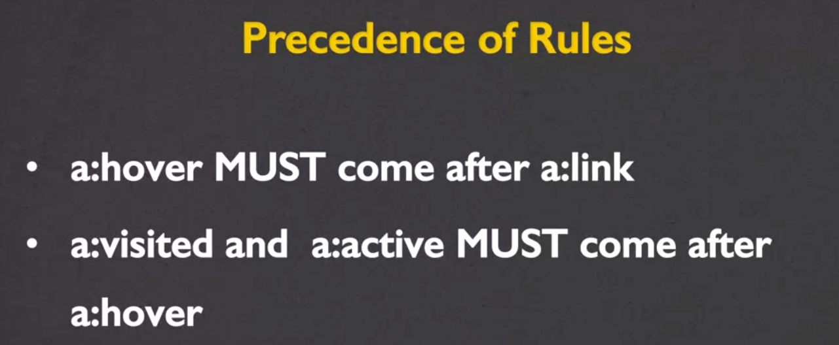

There is a bit of an error on this slide. The precedence of rules listed on this slide are correct for a:link and a:active. However, they are incorrect for a:visited. The correct precedence of rules is listed below:

* a:hover MUST come after a:link and a:visited
* a:active MUST come after a:hover

### Styling Lists

Unique styling properties for lists

* list-style-type ( refers to the bullets )
* list-style-image ( replace bullets with images)
  + this property/value says use square as a default but try image first

ul{

list-style-image: squre url(‘icon.gif’);

}

* list-style-position
* list-style

### Element Dimensions

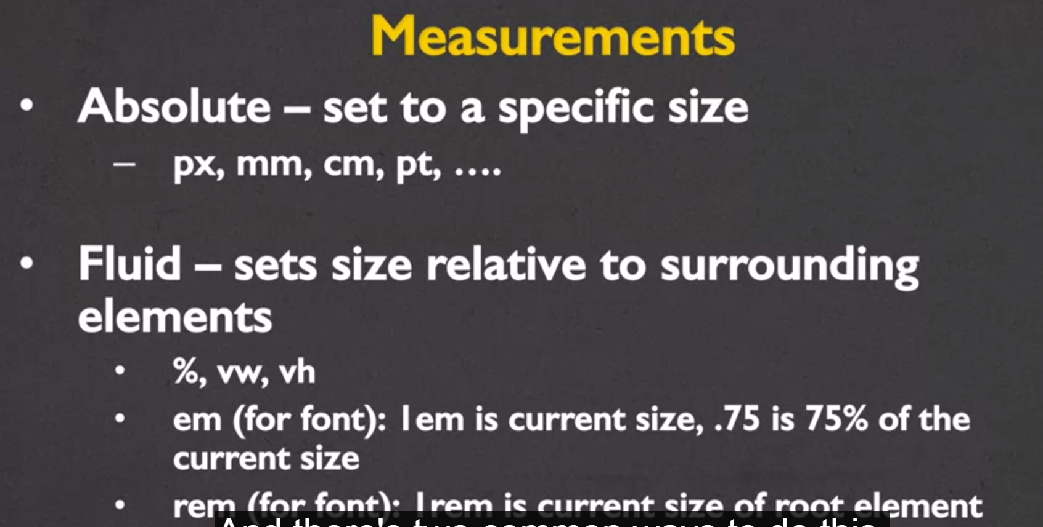

## Advance Selectors

<https://learn.shayhowe.com/advanced-html-css/complex-selectors/> (great resources for understanding adv. Selectors)

To select all elements on the page use the * selector

*{}

## Browser Capabilities

Best way to handle the different browsers tendency to display content according to their style is to create a default stylesheet and link it to your project before all other stylesheets.

Remember that just as not all browsers support all html5 tags, this exception applies to CSS3 styles.

To handle unsupported properties use browser prefixes (or vendor prefixes). These provide a quick fix for handling unsupported CSS3



### Often Unsupported Properties

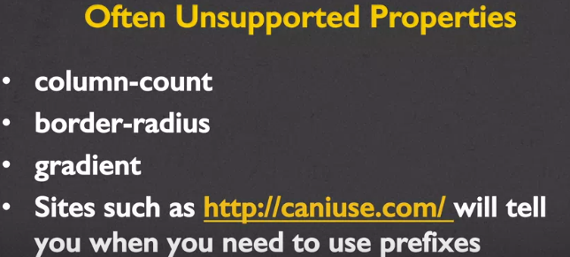

### Automating prefixes

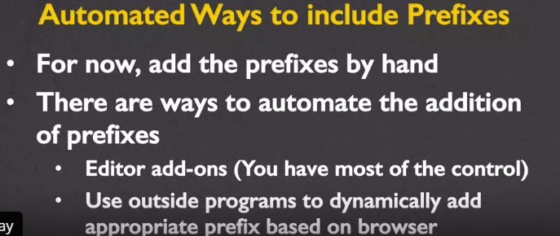

Background Images and Opacity

Standard format for adding background-image

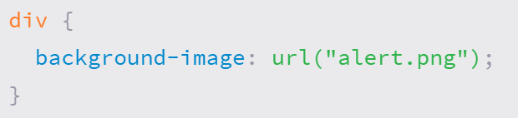

You can control exactly where the background image is placed relative to the parent upper left corner with the background-position property. To set a background-position value, we can use the top, right, bottom, left, and center keywords, pixels, percentages, or any length measurement. Keywords and percentages work very similarly. The keyword value left top is identical to the percentage value 0 0, which will keep an image positioned at the left top corner of the element. The keyword value right bottom is identical to the percentage value 100% 100%, which will position an image in the right bottom corner of the element.

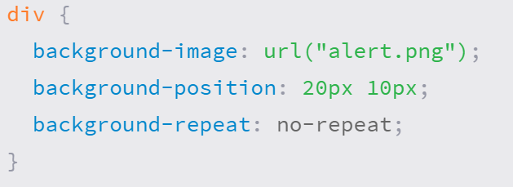

Horizontal offset and vertical offer for positioning

* Shorthand background images

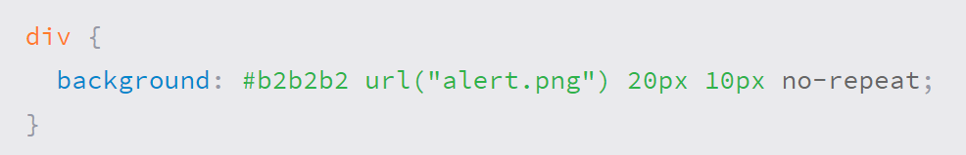

## Selectors (<https://learn.shayhowe.com/advanced-html-css/complex-selectors/>)

#### Common Selectors Overview

| **Example** | **Classification** | **Explanation** |
| --- | --- | --- |
| h1 | Type Selector | Selects an element by its type |
| .tagline | Class Selector | Selects an element by the class attribute value, which may be reused multiple times per page |
| #intro | ID Selector | Selects an element by the ID attribute value, which is unique and to only be used once per page |

#### Child Selectors Overview

| **Example** | **Classification** | **Explanation** |
| --- | --- | --- |
| article h2 | Descendant Selector | Selects an element that resides anywhere within an identified ancestor element |
| article > p | Direct Child Selector | Selects an element that resides immediately inside an identified parent element |

#### Sibling Selectors Overview

| **Example** | **Classification** | **Explanation** |
| --- | --- | --- |
| h2 ~ p | General Sibling Selector | Selects an element that follows anywhere after the prior element, in which both elements share the same parent |
| h2 + p | Adjacent Sibling Selector | Selects an element that follows directly after the prior element, in which both elements share the same parent |

#### Attribute Selectors Overview

| **Example** | **Classification** | **Explanation** |
| --- | --- | --- |
| a[target] | Attribute Present Selector | Selects an element if the given attribute is present |
| a[href="http://google.com/"] | Attribute Equals Selector | Selects an element if the given attribute value exactly matches the value stated |
| a[href*="login"] | Attribute Contains Selector | Selects an element if the given attribute value contains at least once instance of the value stated |
| a[href^="https://"] | Attribute Begins With Selector | Selects an element if the given attribute value begins with the value stated |
| a[href$=".pdf"] | Attribute Ends With Selector | Selects an element if the given attribute value ends with the value stated |
| a[rel~="tag"] | Attribute Spaced Selector | Selects an element if the given attribute value is whitespace-separated with one word being exactly as stated |
| a[lang|="en"] | Attribute Hyphenated Selector | Selects an element if the given attribute value is hyphen-separated and begins with the word stated |

#### Pseudo-classes Overview

| **Example** | **Classification** | **Explanation** |
| --- | --- | --- |
| a:link | Link Pseudo-class | Selects a link that has not been visited by a user |
| a:visited | Link Pseudo-class | Selects a link that has been visited by a user |
| a:hover | Action Pseudo-class | Selects an element when a user has hovered their cursor over it |
| a:active | Action Pseudo-class | Selects an element when a user has engaged it |
| a:focus | Action Pseudo-class | Selects an element when a user has made it their focus point |
| input:enabled | State Pseudo-class | Selects an element in the default enabled state |
| input:disabled | State Pseudo-class | Selects an element in the disabled state, by way of the disabled attribute |
| input:checked | State Pseudo-class | Selects a checkbox or radio button that has been checked |
| input:indeterminate | State Pseudo-class | Selects a checkbox or radio button that neither been checked or unchecked, leaving it in an indeterminate state |
| li:first-child | Structural Pseudo-class | Selects an element that is the first within a parent |
| li:last-child | Structural Pseudo-class | Selects an element that is the last within a parent |
| div:only-child | Structural Pseudo-class | Selects an element that is the only element within a parent |
| p:first-of-type | Structural Pseudo-class | Selects an element that is the first of its type within a parent |
| p:last-of-type | Structural Pseudo-class | Selects an element that is the last of its type within a parent |
| img:only-of-type | Structural Pseudo-class | Selects an element that is the only of its type within a parent |
| li:nth-child(2n+3) | Structural Pseudo-class | Selects an element that matches the given number or expression, counting all elements from the beginning of the document tree |
| li:nth-last-child(3n+2) | Structural Pseudo-class | Selects an element that matches the given number or expression, counting all elements from the end of the document tree |
| p:nth-of-type(3n) | Structural Pseudo-class | Selects an element that matches the given number or expression, counting only elements of its type from the beginning of the document tree |
| p:nth-last-of-type(2n+1) | Structural Pseudo-class | Selects an element that matches the given number or expression, counting only elements of its type from the end of the document tree |
| section:target | Target Pseudo-class | Selects an element whose ID attribute value matches that of the URI fragment identifier |
| div:empty | Empty Pseudo-class | Selects an element that does not contain any children or text nodes |
| div:not(.awesome) | Negation Pseudo-class | Selects an element not represented by the stated argument |

#### Pseudo-elements Overview

| **Example** | **Classification** | **Explanation** |
| --- | --- | --- |
| .alpha:first-letter | Textual Pseudo-elements | Selects the first letter of text within an element |
| .bravo:first-line | Textual Pseudo-elements | Selects the first line of text within an element |
| div:before | Generated Content | Creates a pseudo-element inside the selected element at the beginning |
| a:after | Generated Content | Creates a pseudo-element inside the selected element at the end |
| ::selection | Fragment Pseudo-element | Selects the part of a document which has been selected, or highlighted, by a users’ actions |

Notes

Links

<https://codepen.io/ColleenEMc/collections/> ( codepin repository)

<http://caniuse.com/> (list browser supported/unsupported CSS properties)

Closing Thoughts

## **The four principals of Accessibility**

The industry standard guidelines for web content **accessibility** are organized around **four principles**: Perceivable, Operable, Understandable, and Robust (or POUR). To help you understand the basics of **accessibility**, we've put together an introduction to these **principles**.

Week 3

Notes

# Advance Ideas

### Transitions

When adding transitions to your CSS you will need to define several properties:

* Transition-property –What is it you want to change (size,color,position,etc)?
* Transition-duration – How long should each transition last?
* Transition-timing – Should it be a smooth transition (linear)? Or different?
* Transition-delay – wait time before transition beings

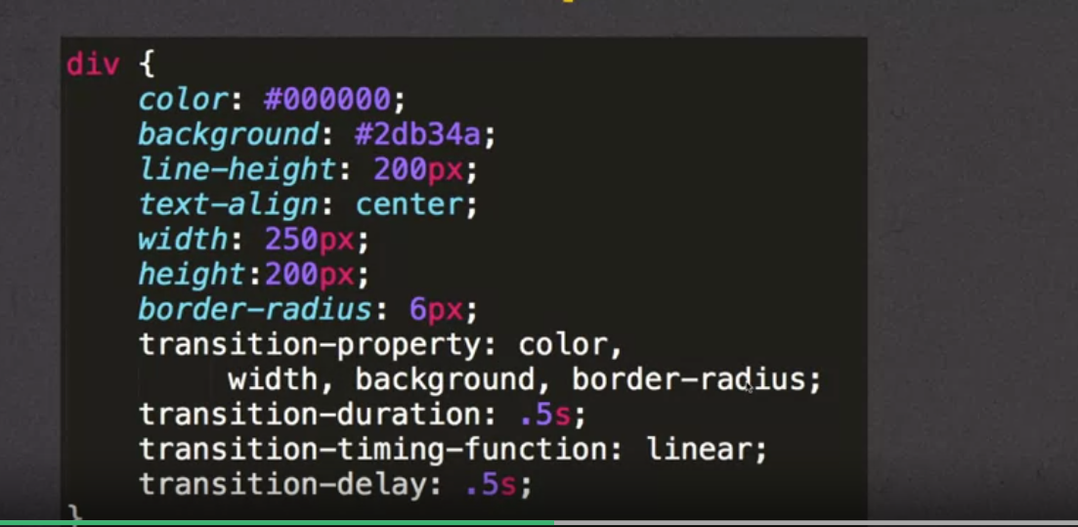

#### Using Shorthand for transitions

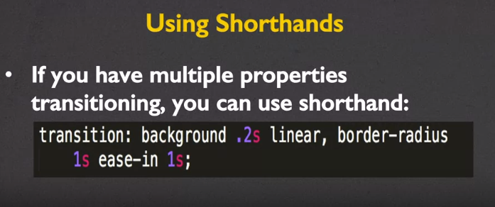

### Transforms

When you want to change an element’s 2D/3D properties use transforms.

2D transforms options include:

* Translate 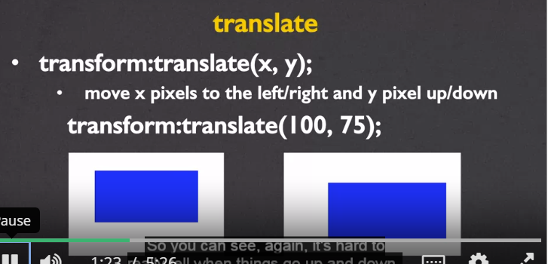
* Rotate 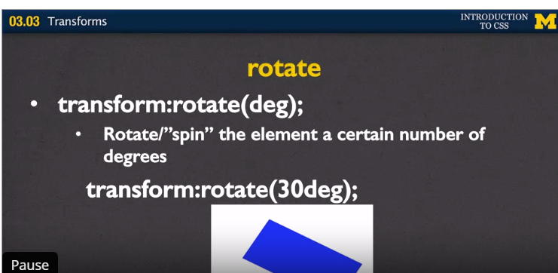
* Scale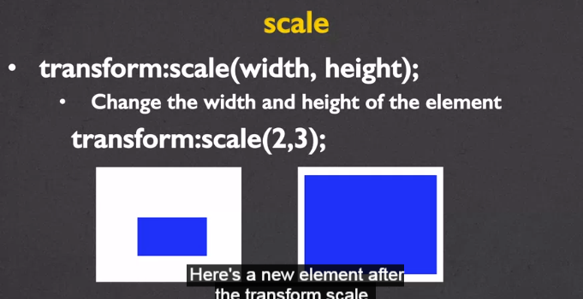
* Skew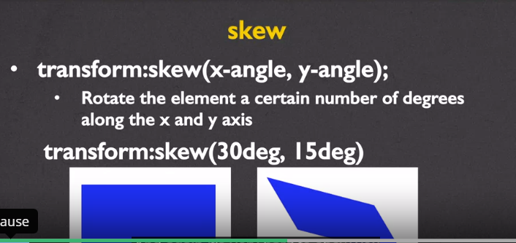
* Matrix- combines all of the 2D transforms methods into one(shorthand)

#### 3D transforms

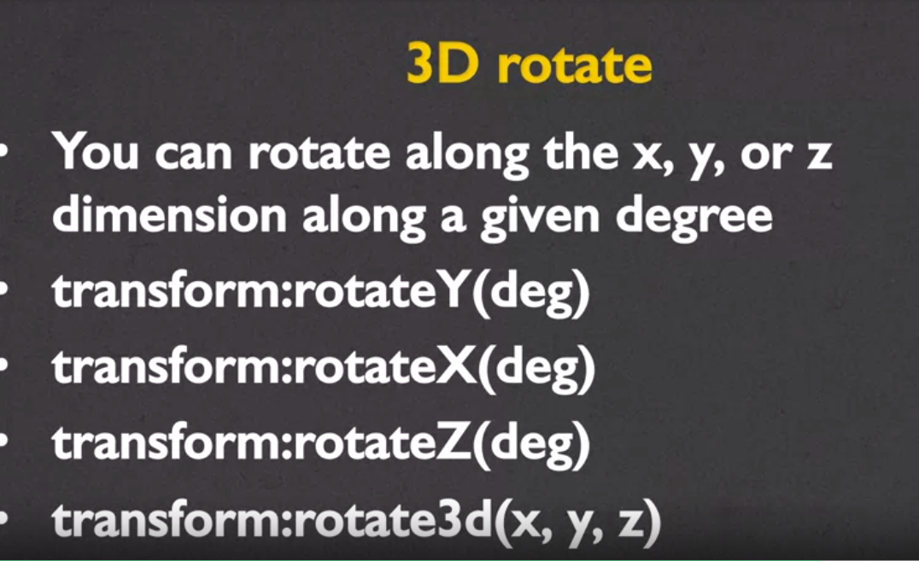

## Positioning

There are four position properties that you can manipulate: static, relative, absolute and fixed

#### Static

The browser default

#### Relative

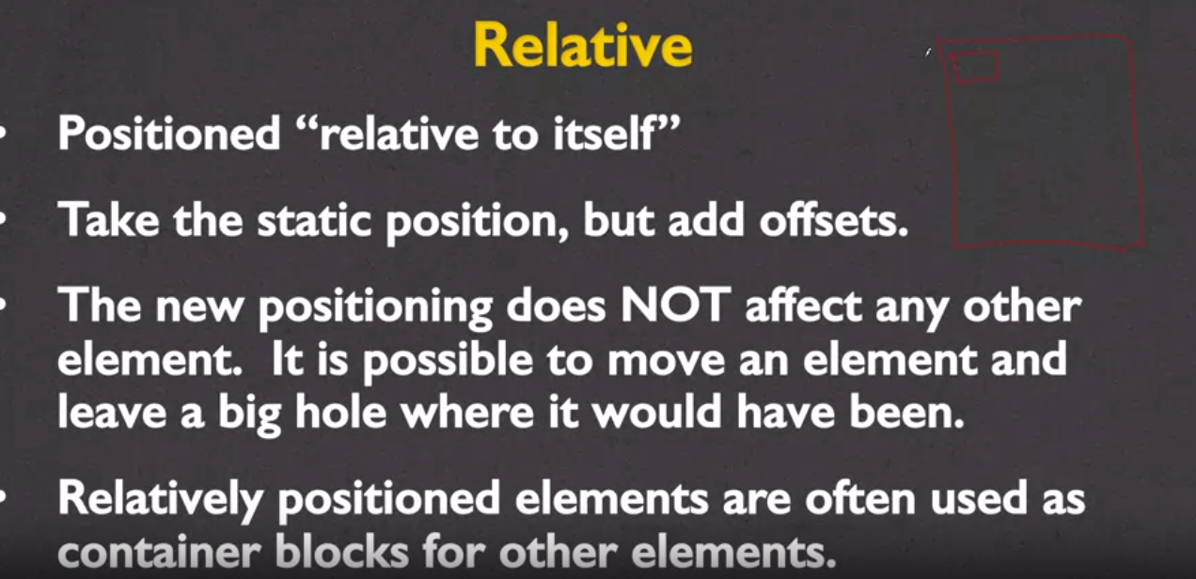

#### Absolute

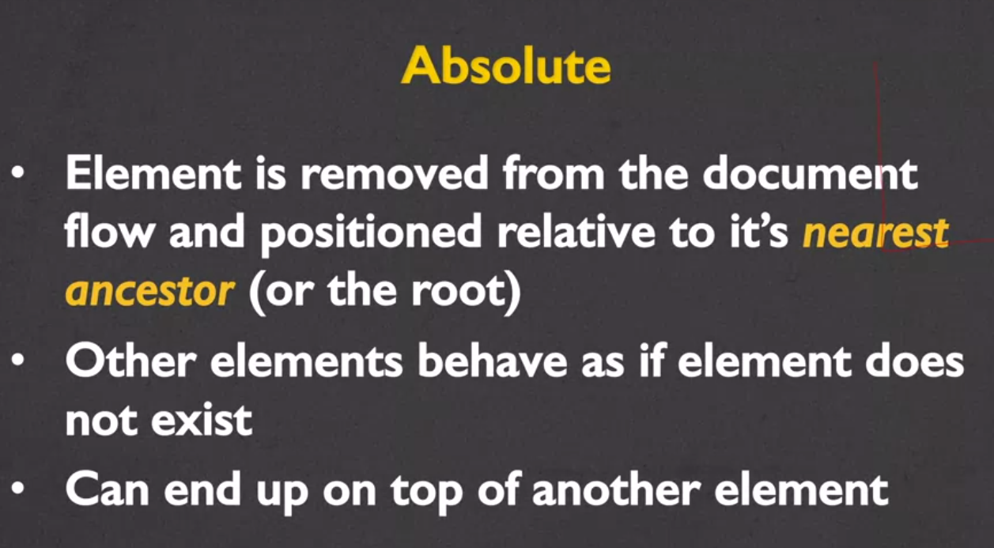

#### Fixed

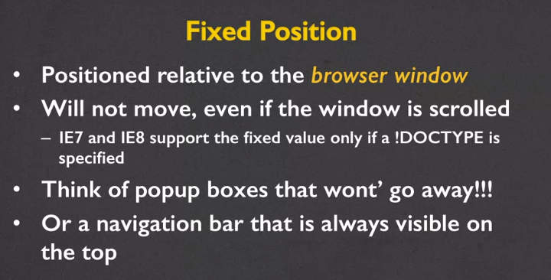

Links

Optional Readings:

1. [CSS3 Transitions](http://www.w3schools.com/css/css3_transitions.asp) - from W3 Schools
2. [Transitions and Animations](http://learn.shayhowe.com/advanced-html-css/transitions-animations/) - Shay Howe
3. [CSS: Animation Using CSS Transforms](http://www.the-art-of-web.com/css/css-animation/)
4. [22 stunning examples of CSS3 animation](http://www.creativebloq.com/css3/animation-with-css3-712437)

### Some Fun Links - Optional

[18 Cool Things You Won’t Believe Were Built Using CSS](http://www.hongkiat.com/blog/built-with-css/)

[12 Awesome CSS3 Features That You Can Finally Start Using](http://tutorialzine.com/2013/10/12-awesome-css3-features-you-can-finally-use/)

Closing Thoughts

Week 4

Notes

# OPTIONAL: A Change to the Accessibility of Headings

It used to be that the general rule was one <h1> heading per page. However, with the advent of HTML5 and its many container elements (aside, section, article, etc.) this rule has changed. Here is a link to an interesting article that explains why multiple <h1> headings will probably improve the accessibility ***and*** search engine optimization of your page.

<http://webdesign.tutsplus.com/articles/the-truth-about-multiple-h1-tags-in-the-html5-era--webdesign-16824>

But just to be difficult, I will include this link to someone who disagrees.

<https://yoast.com/headings-use/>

Links

Closing Thoughts

# Closing Thoughts